**HERITAGE INSTITUTE OF TECHNOLOGY**



**TOPIC: ONLINE HOTEL MANAGEMENT SYSTEM**

**BY:-**

**Name - ANKESH KUMAR**

**Roll – 1452140**

**Dept – ECE-C (4th year)**

**CONTENTS**

* Introduction 03
* Functional Requirements 04
* Non-Functional Requirements 05
* Hardware Requirements 06
* Software Requirements 07
* Feasibility Analysis 08
* Data Flow Diagram 10
* Database Tables 12
* White-Box Testing 13
* Future Scope 25
* Conclusion 26

**INTRODUCTION**

**There are various activities performed in a HOTEL. The motive of this project is to control those hotel related activities.**

**In present time there is a great rush of hotels, as they have become necessity for the people. People travel a lot, stay in hotels for functions, meetings and many other works.**

**This software developed is for a hotel, in which the guests can easily book a room through its online facility. The payment option is also present for the easy transaction.**

**Implementation of this Hotel Management System will definitely bring lots of benefits to the hotel, as well as the user.**

**FUNCTIONAL REQUIREMENTS**

**The site should be designed to allow any users to search database from hotel system database. The system should allow customer to view information of rooms and hotel and allow customer to book the records in the database, accept the payment and provide confirmation. Other function that could increase the usability of a website is:**

1. **Automatic email confirmation of the room booking.**
2. **Confirmation of payment details.**
3. **Provide list of room available**

**Functional requirements define the fundamental actions that system must perform. The functional requirements for the system are divided into THREE main categories.**

1. **Admin module**
   1. **Can view employee list and can remove employee.**
   2. **Can view all the guest list and can see the payment**
   3. **Can see money collection on particular date**
   4. **Can view feedback**
2. **User module**
   1. **Can register itself**
   2. **Can login**
   3. **Check room availability**
   4. **Book rooms**
   5. **Make payment through cards, cash and e-wallet.**
   6. **Can order food.**
   7. **Can check out guest**
   8. **Can give feedback**
   9. **And then can logout.**

**The user should also know the functionalities**

* 1. **How the online hotel system works**
  2. **How to sign-in, login, book rooms**
  3. **How to make payment and save the bill**

**NON-FUNCTIONAL REQUIREMENTS**

**Non-functional requirements define the needs in terms of performance, logical database requirements, design constraints, reliability, availability, security, etc.**

1. **Performance Details**

**Performance details define acceptable response times for system functionality.**

**The load time for the user interface screens shall take no longer that two seconds.**

**The login verification shall be done in less than one seconds.**

**Queries shall return results within two seconds.**

1. **Logical Database Details**

**The logical database requirements include the retention of the following data elements. This list is not a complete list and is designed as a starting point for development.**

**BOOKING/RESERVATION SYSTEM**

* **Customer’s first name**
* **Last name**
* **Phone number**
* **Number of occupants**
* **Assigned room**
* **Room rate**
* **Booked(yes/no)**
* **Check-in date**
* **Check-out date**

**HARDWARE REQUIREMENTS**

1. **Hard disk: The database connectivity requires a hardware configuration with a fast database system running on high rpm hard-disk permitting complete data redundancy and back-up systems to support the primary goal of reliability.**

**500GB**

1. **The system must interface with the standard output device, keyboard and mouse to interact with this software.**
2. **OS: windows 8.1 or above.**

**SOFTWARE REQUIREMENTS**

* **Developer**
  + **Php(Wamp)**
  + **Mysqli**
  + **Text editor(Sublime text, Notepad++, Notepad)**
* **User**
  + **Web browser:**

**FEASIBILITY ANALYSIS**

**Feasibility Study is to check the viability of the project under consideration . Theoretically various types of feasibilities are conducted, they are explained as under:**

**Technical Feasibility: The criteria for technical feasibility of Online Hotel Management System are:**

**● Easy to use : The users are assumed to be normal ordinary people having knowledge of simple computer operation , so ease of use is a very essential factor if we want to get the job actually done quickly.**

* **Correctness: A good software design should correctly implement all the functionality of the system.**

**● Security: As login name and passwords are used at login time , the security is maintained . Some functions are to be kept under control of some specific authority , so that password protected entry is used or password should be encrypted .**

**● Compatibility : Our software makes it possible to extend an existing class or interface by adding new methods and properties .**

**● Reliability : As tables are used for storing the data , the reliability is maintained as exact data is retrieved . Data is regained from each table by using a unique key so**

**that the accurate record is accessed .**

**● Maintainability :Maintenance usually comprises of :**

* **Updation :As the project is built with keeping in mind all the necessary functions , no essential updation is required .**

**● Portability :As the size of the project code is enormous , a CD can be used to transfer it from one server to other . If required , data can also be moved using secondary memory devices . So , it is portable to a great extent .**

**● Re-usability : The extensibility and portability of this project would make it reusable software .**

**● Serviceability : This project will try to provide maximum possible service to the user .**

**● Software : The software which we have used to develop our project includes mysqli and using localhost as the server and PHP as a general-purpose scripting language for web development.**

## Economical Feasibility:

**This system made is cost effective and does not require much resources.**

**Intangible Benefits:**

1. **More timely update.**
2. **Increased Flexibility.**
3. **Ease to access.**
4. **Information processing gets more efficient and accurate.**
5. **Payment gets easier.**
6. **Improved resource control.**
7. **Decreases paperwork and hence is more environmental friendly.**
8. **Easy to maintain.**

**2.DATA FLOW DIAGRAM**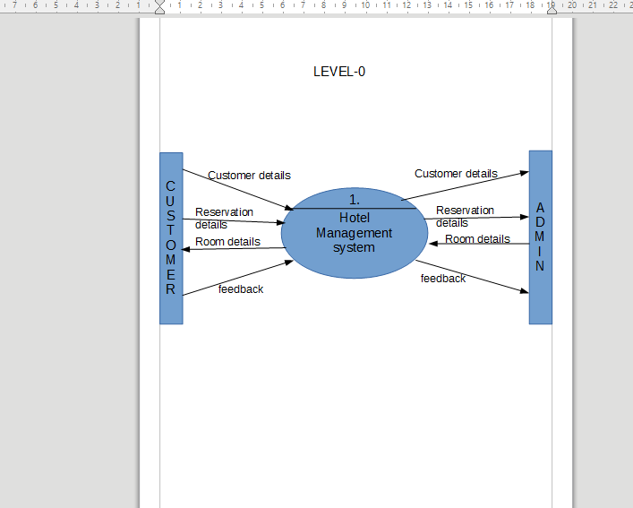

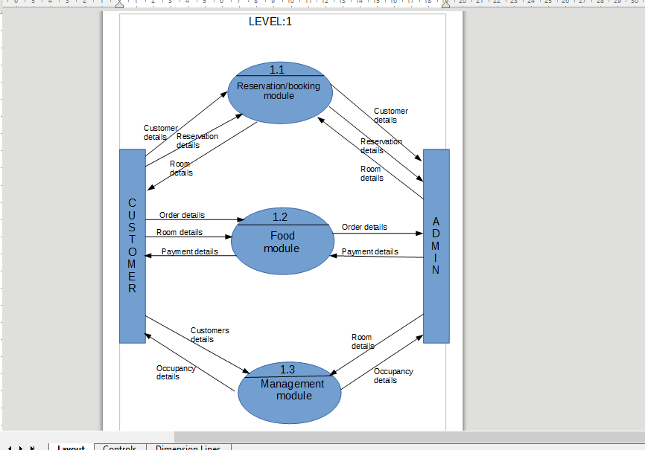

**DATABASE TABLES**

1. **Database 1(db1)**

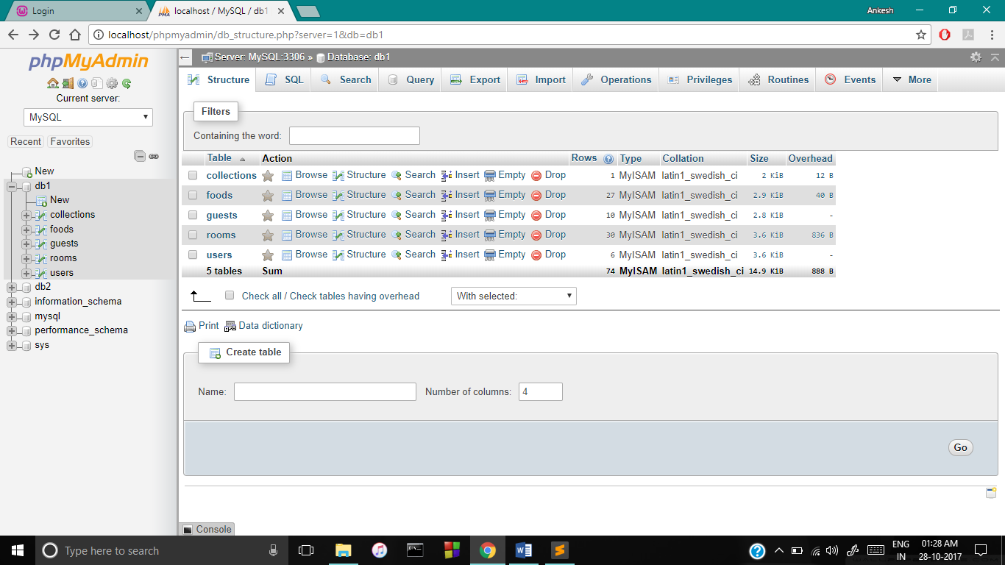

1. **Database 2(db2)**

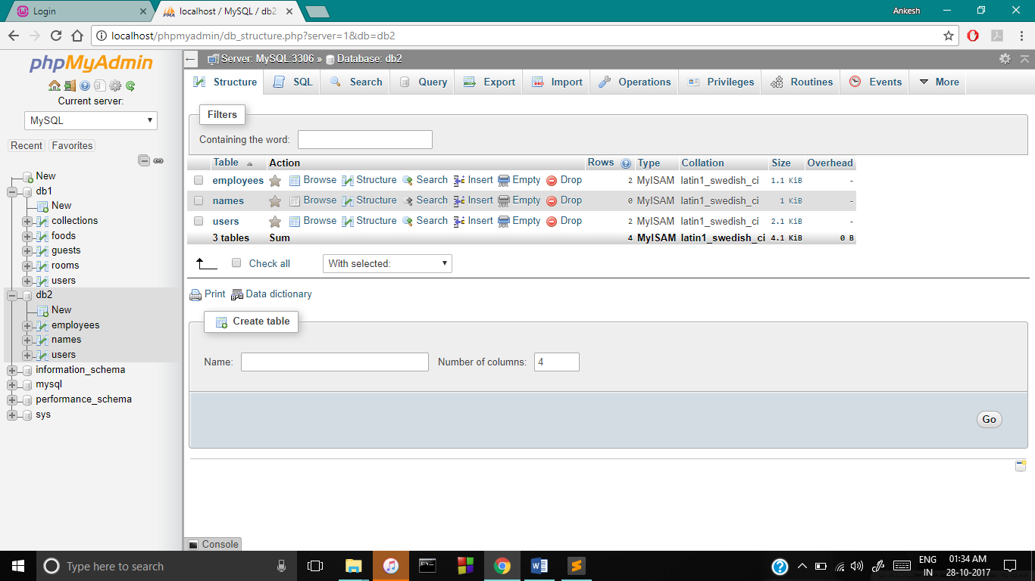

**WHITE BOX TESTING**

**White box testing is a testing technique that examines the program structure and derives test data from the program logic/code. The other names of glass box testing are clear box testing, open box testing, logic driven testing or path driven testing or structural testing.**

1. **Here user can login or register**

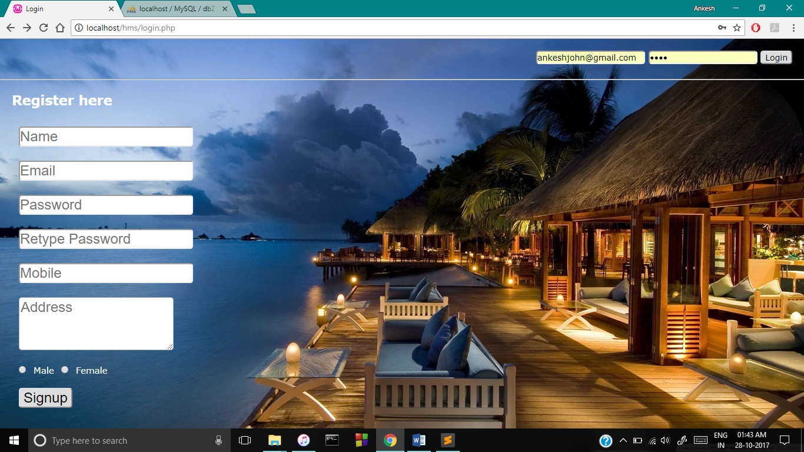

**Code for registration(Signup)**

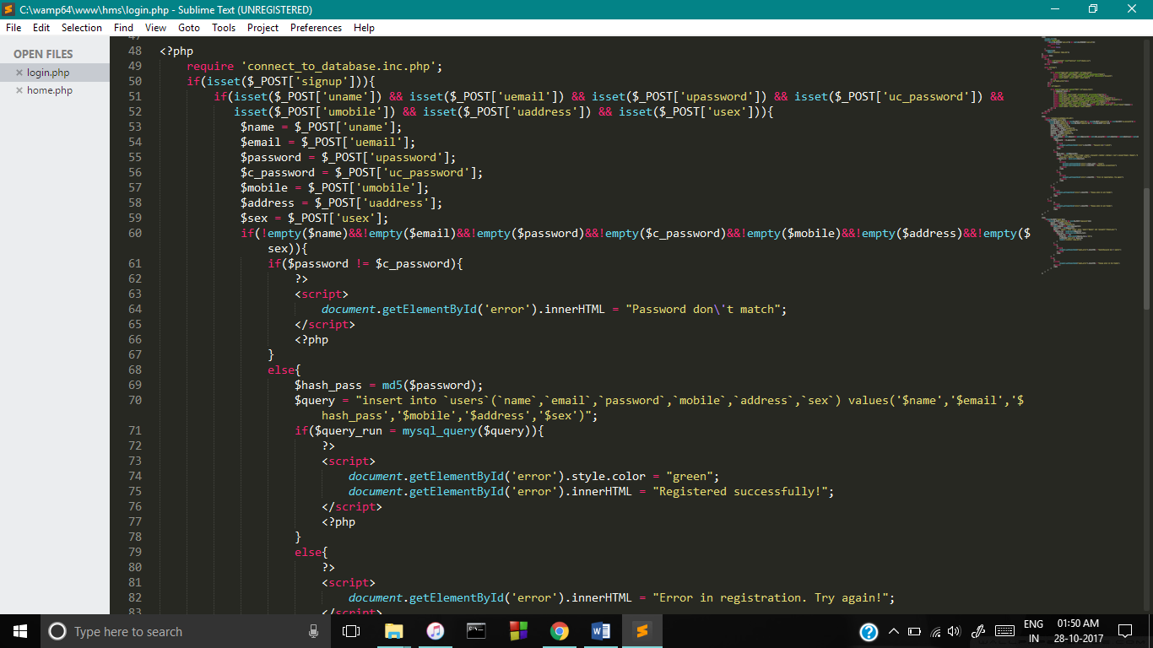

**Code for login(check if email and password are correct or not**

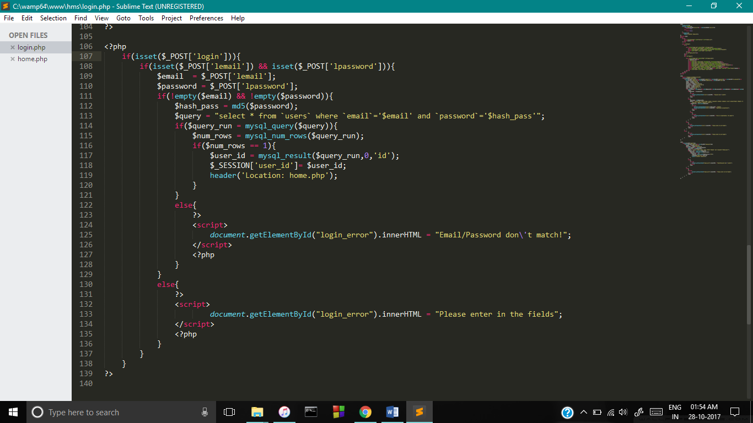

1. **Home page after login**

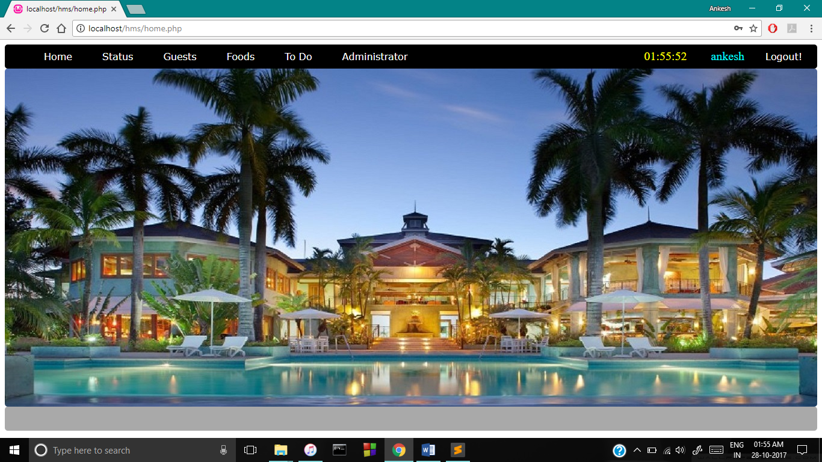

1. **Status- It shows the status of the hotels if vacant or not**

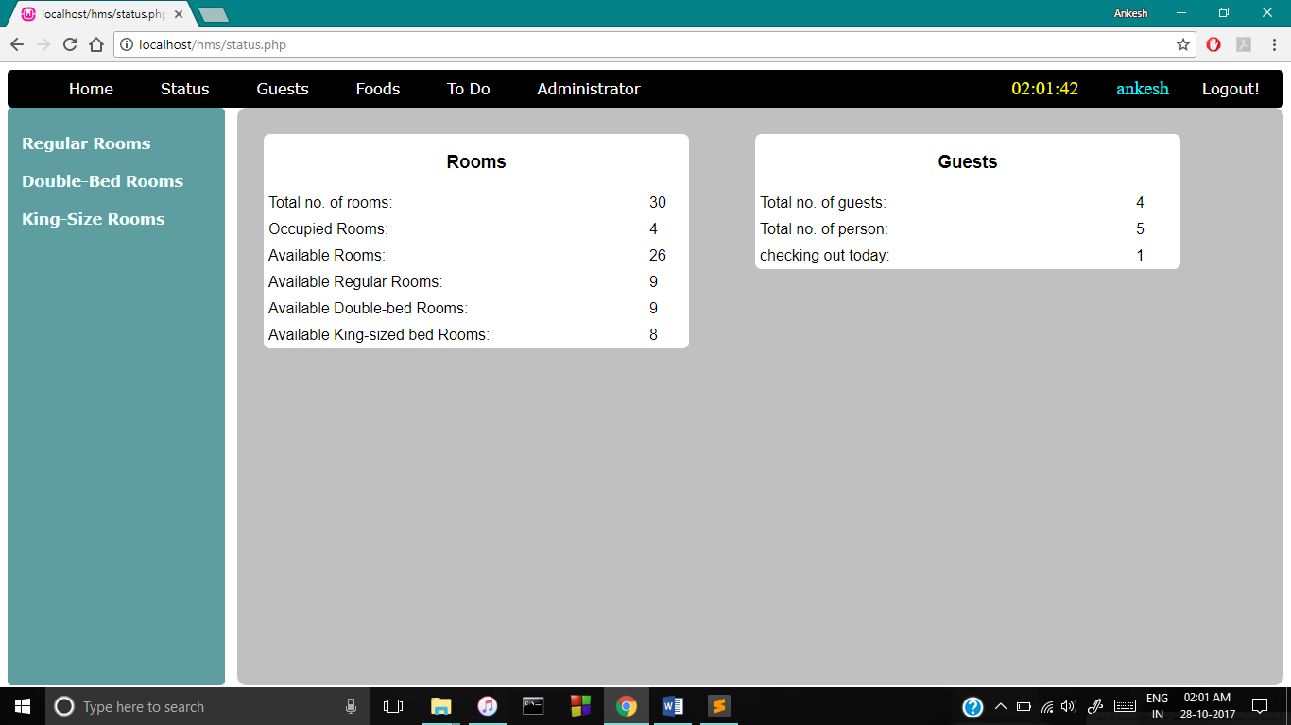

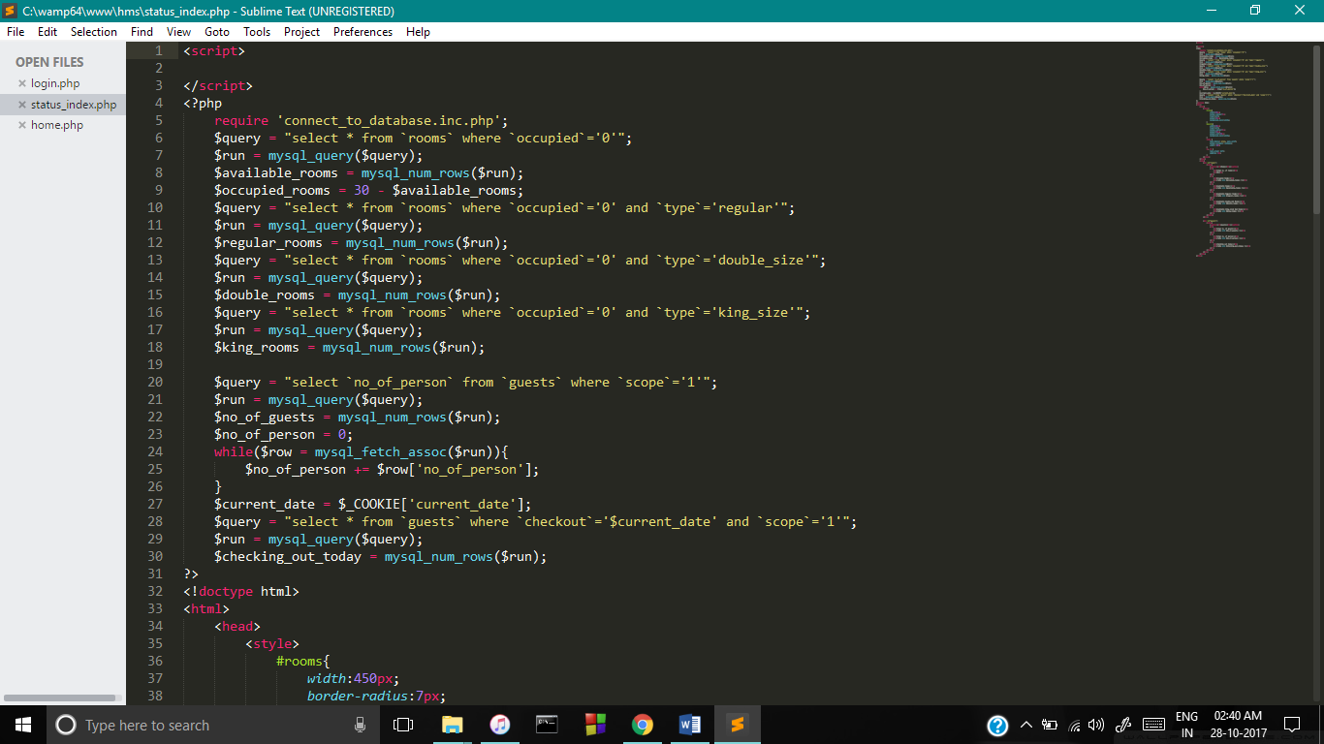

1. **Guest -This section contains the features like add new guests, Guest list to know the details of the guests, and archived guest contains the check outed guests**

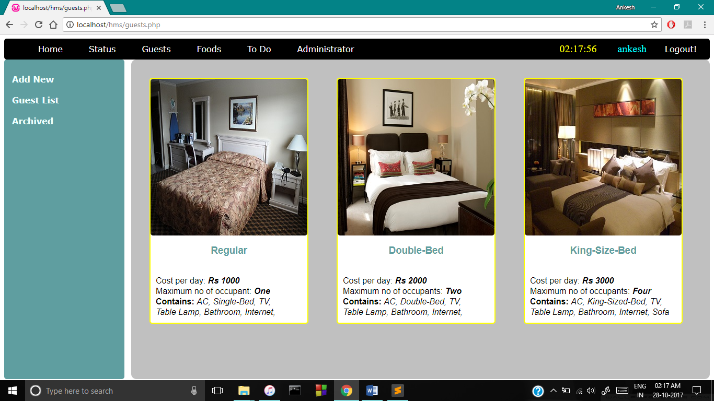

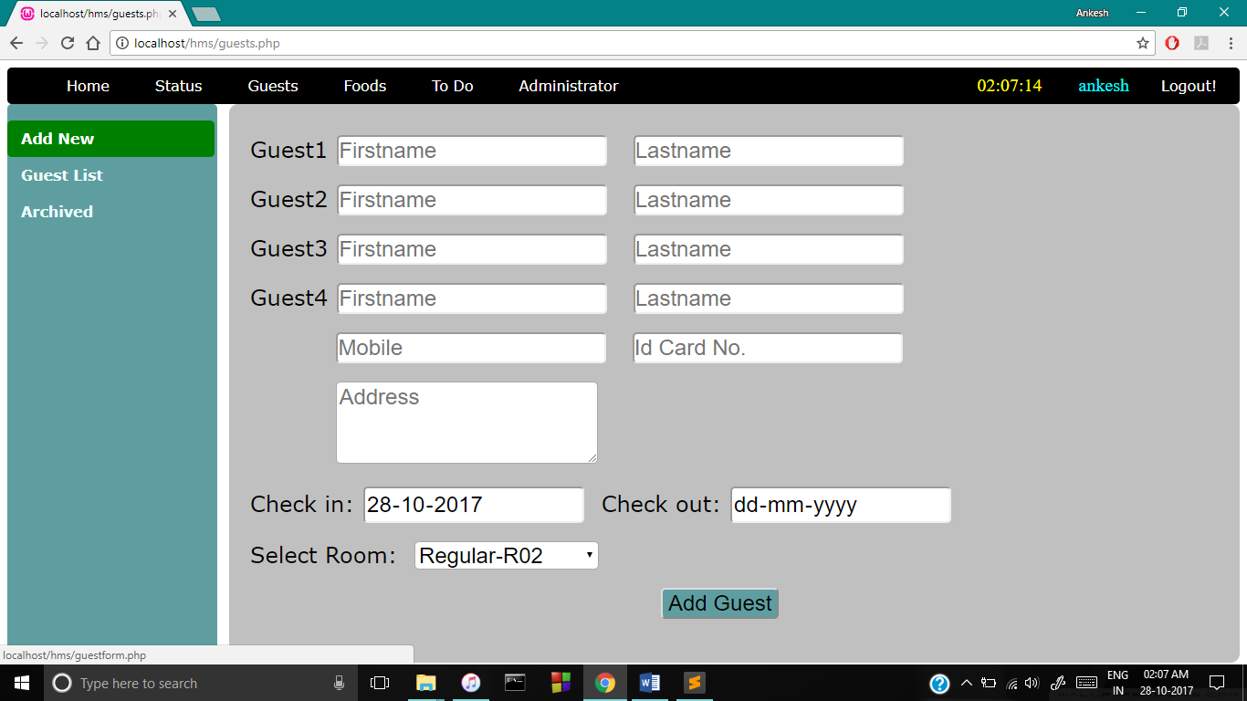

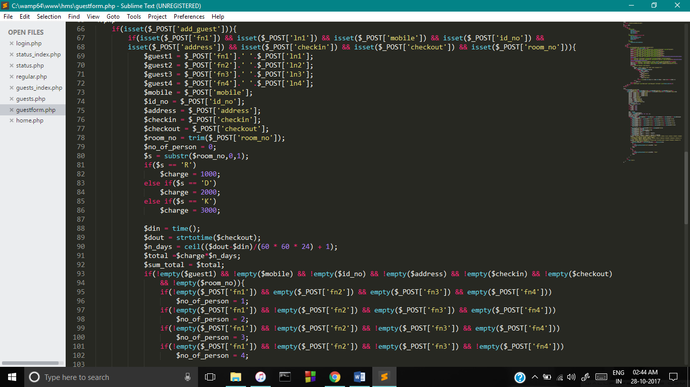

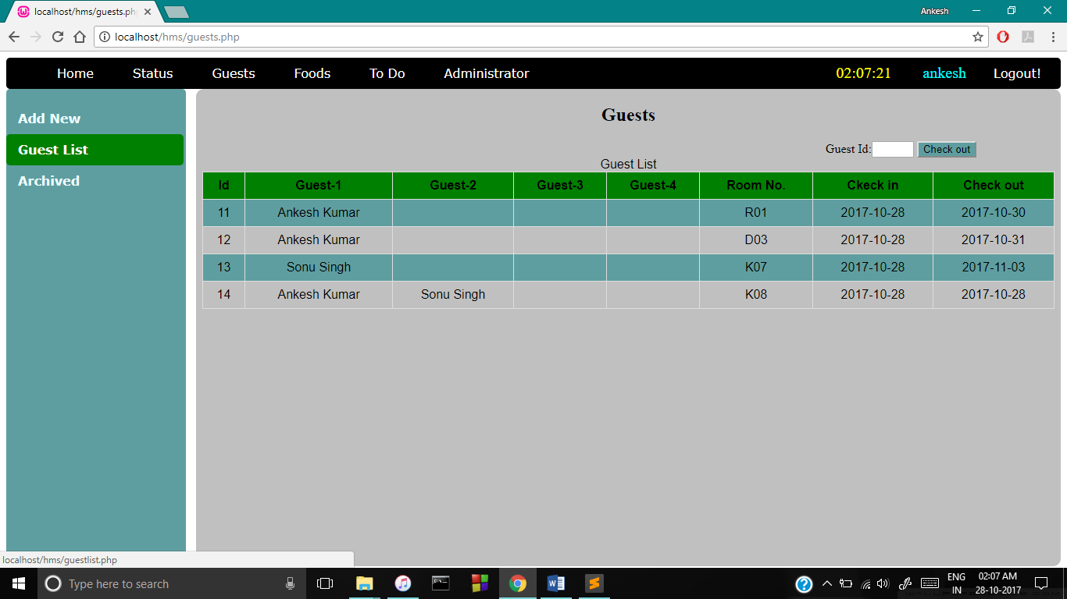

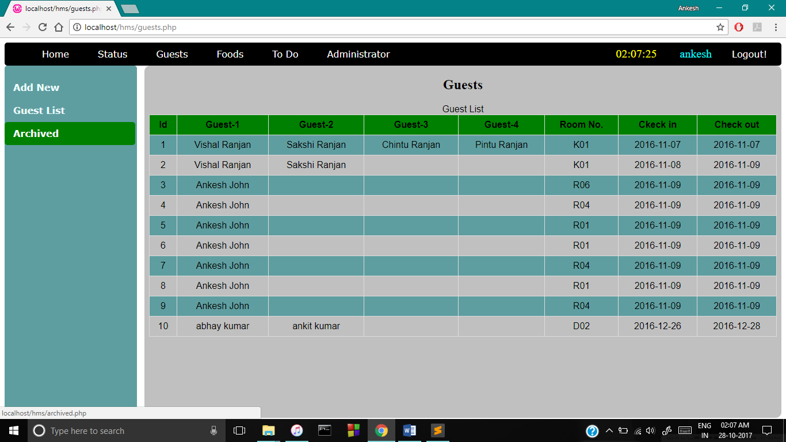

1. **Foods -This section contains the ordering of foods and adding and removing food items. Ordering of foods is done on guest id and the cost receipt is calculated and printed.**

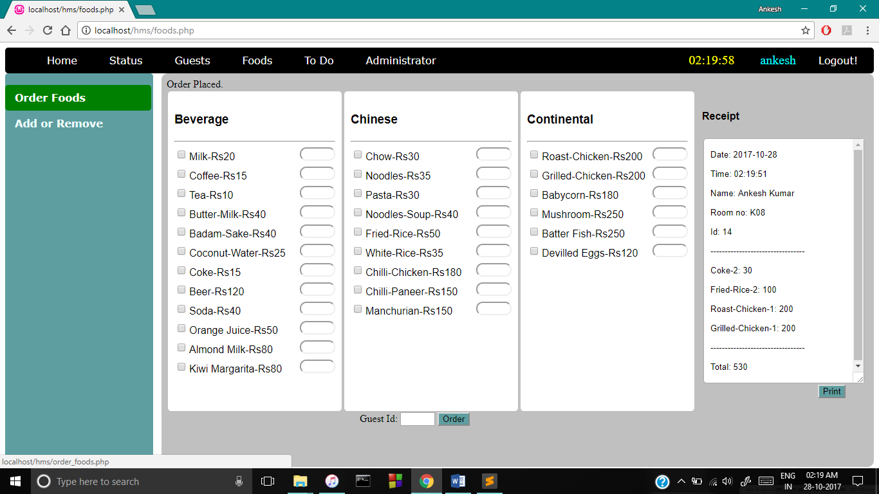

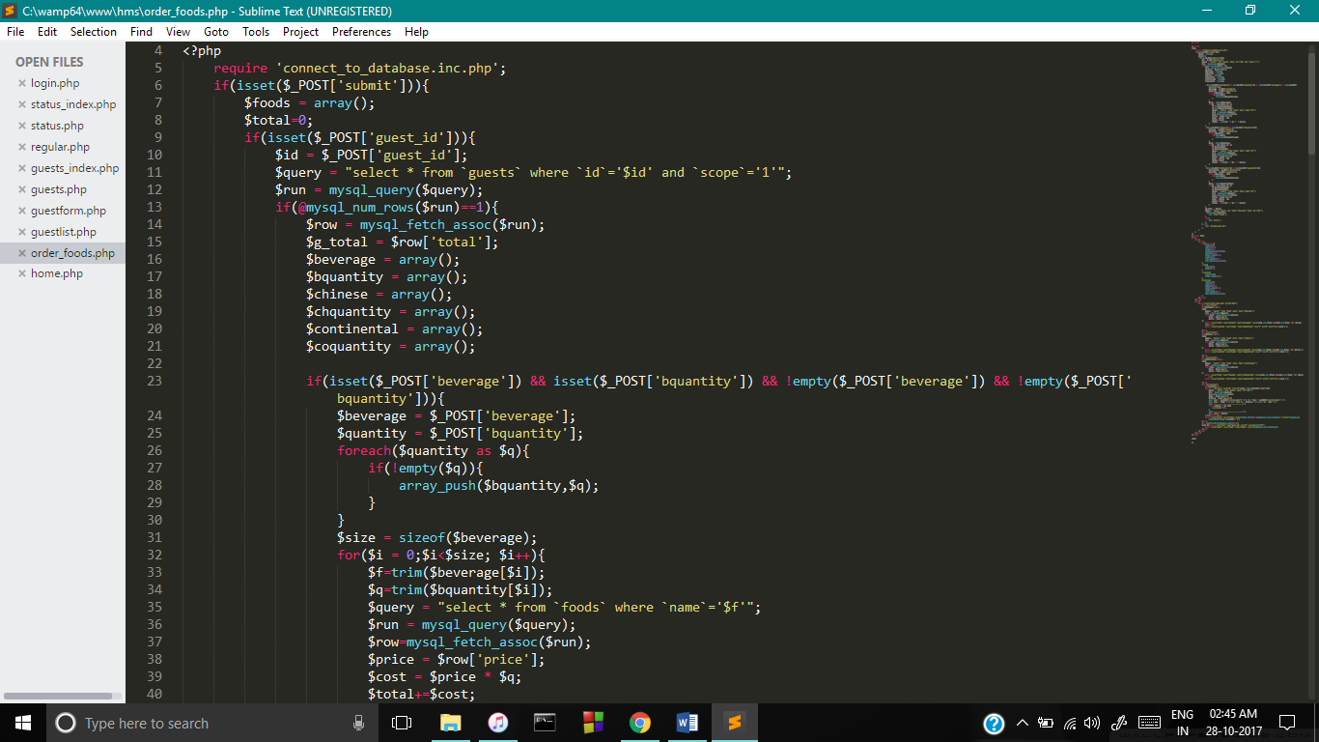

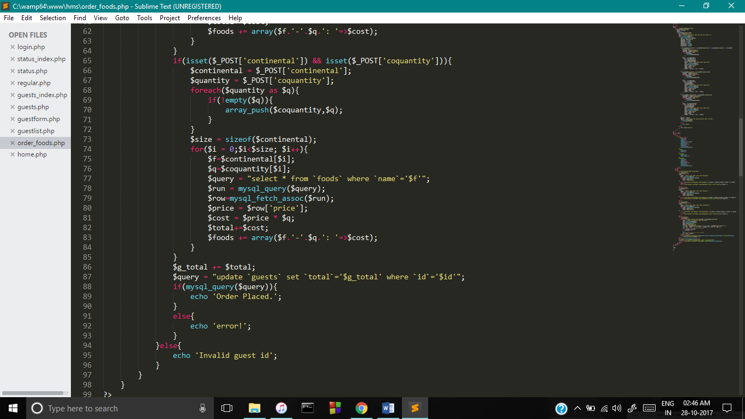

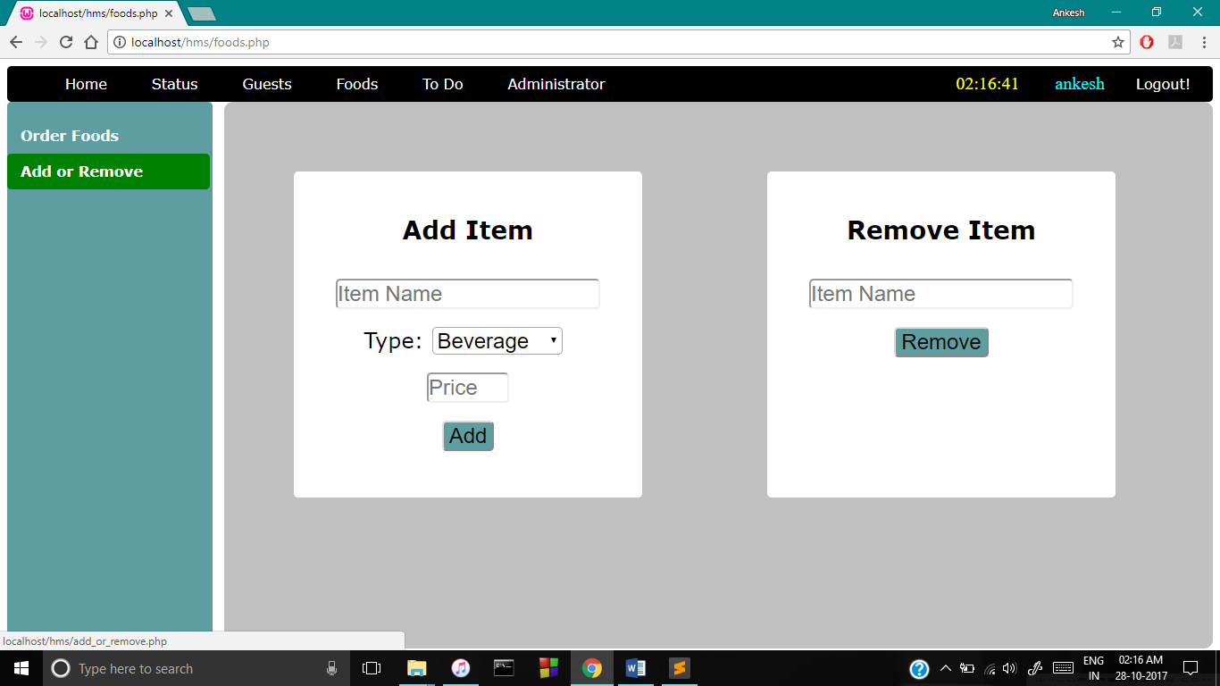

1. **To Do- This section contains the reminder if any guest is checking out today and also contains section to generate guest bill**

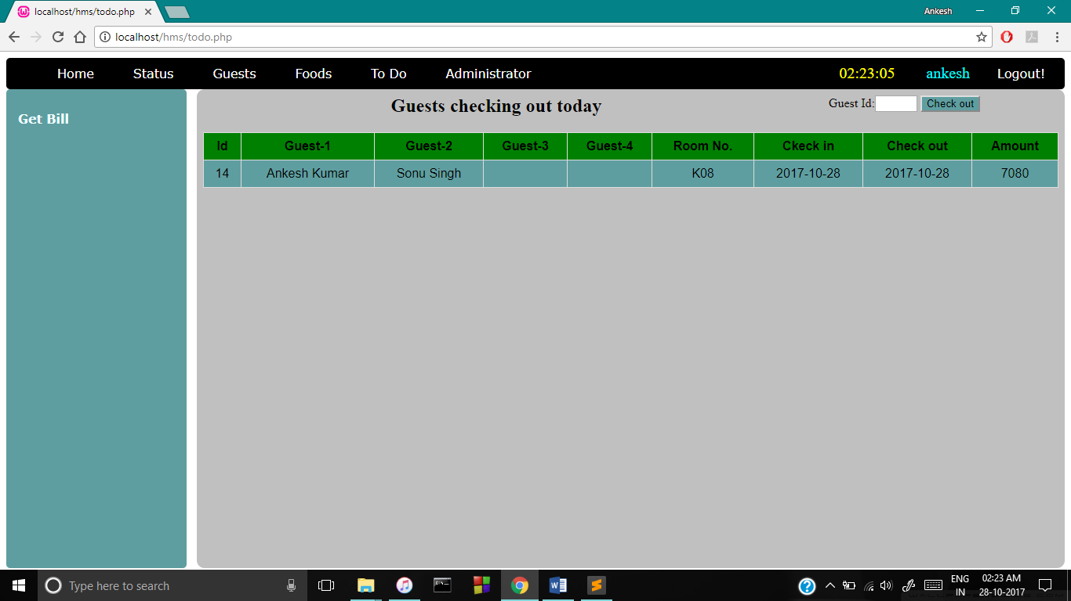

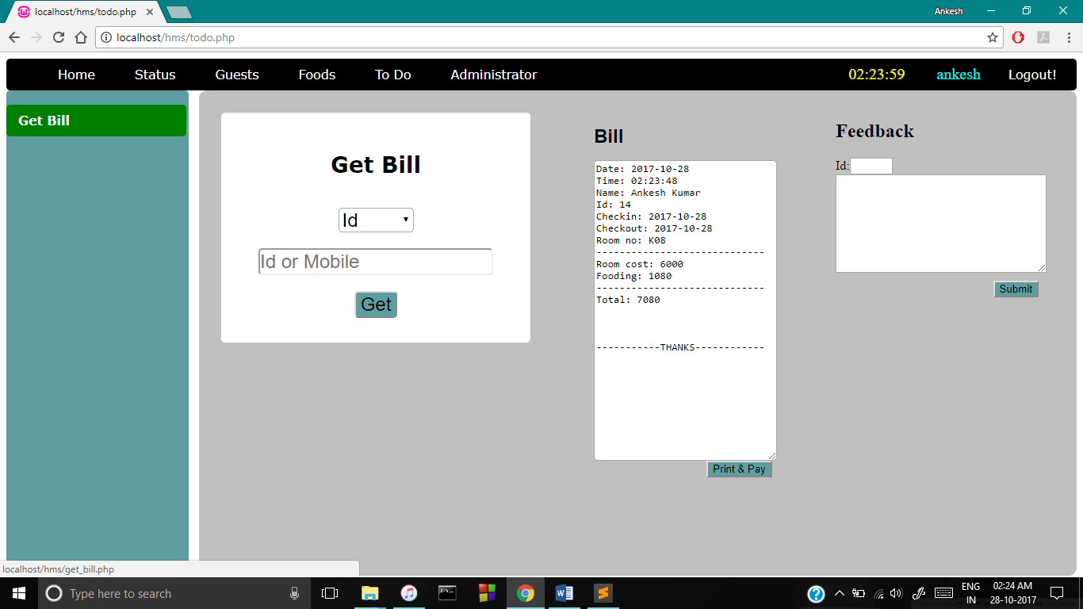

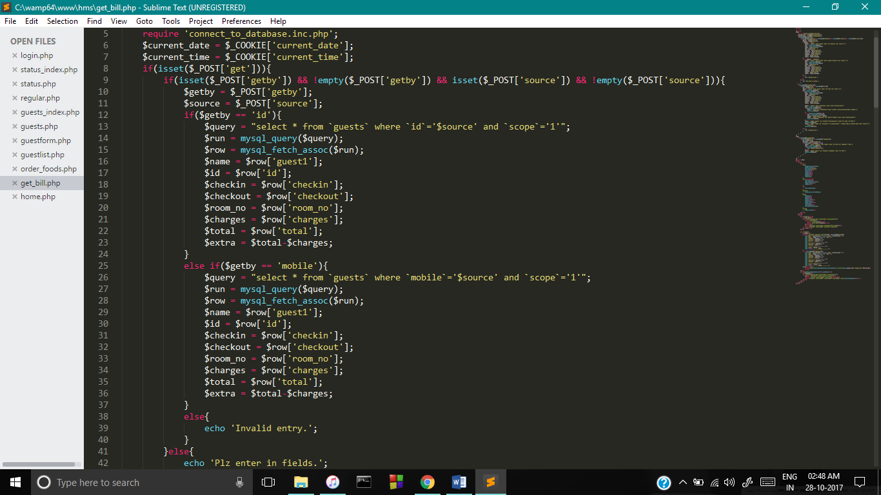

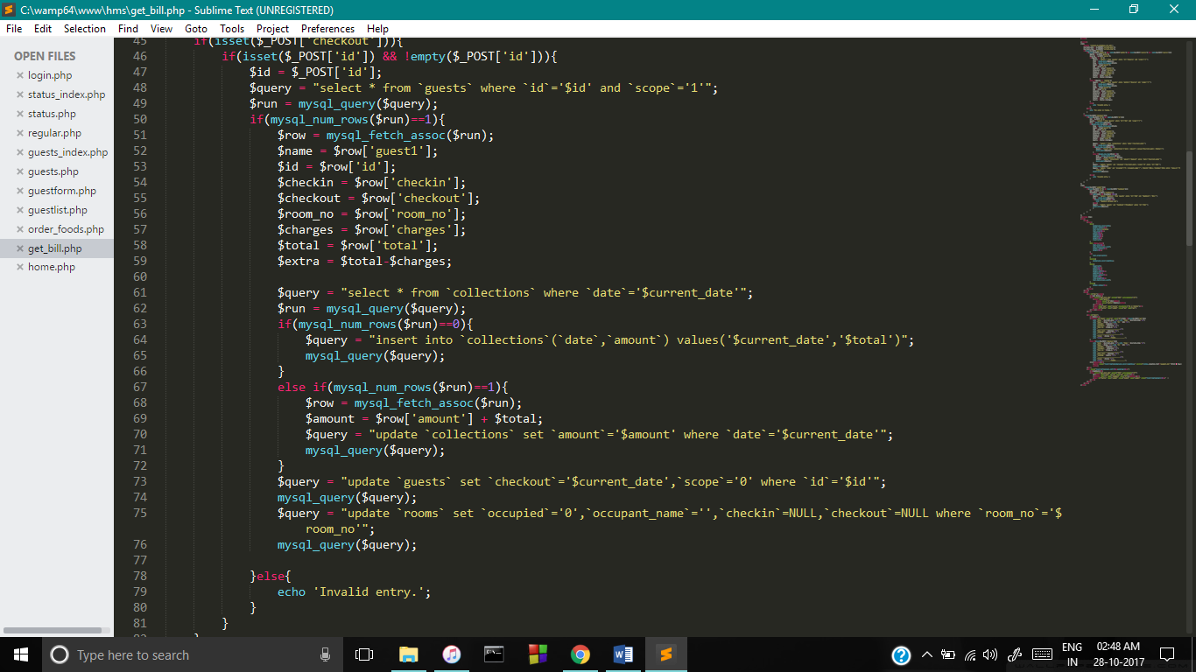

1. **Adminstrator – This section is admin panel where a admin can login and see the details of the employee working in his hotel, Guest list , Collection of money on particular date and feedbacks given by the customers.**

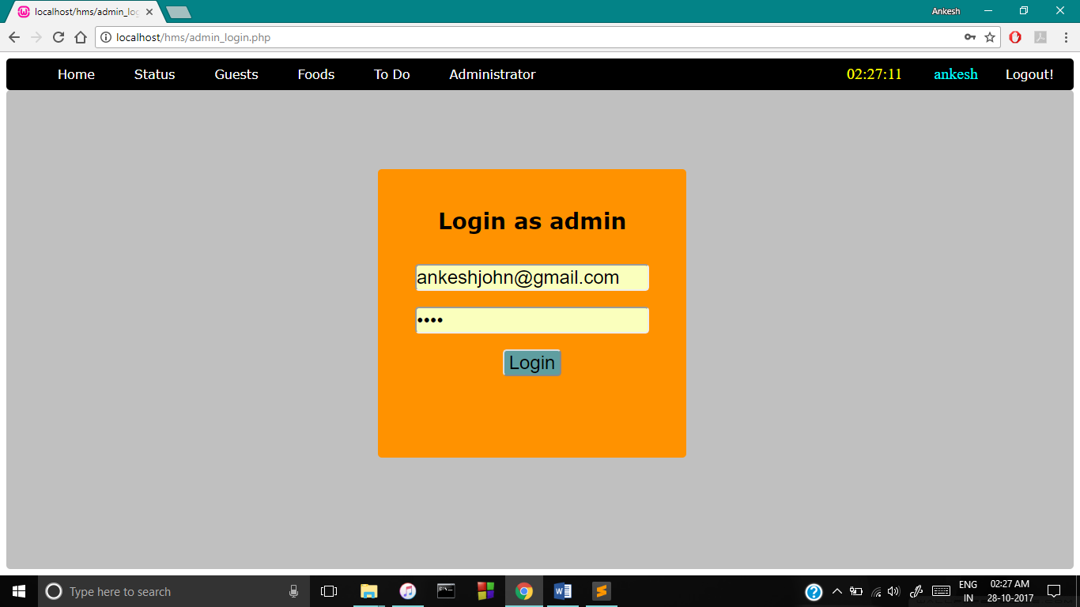

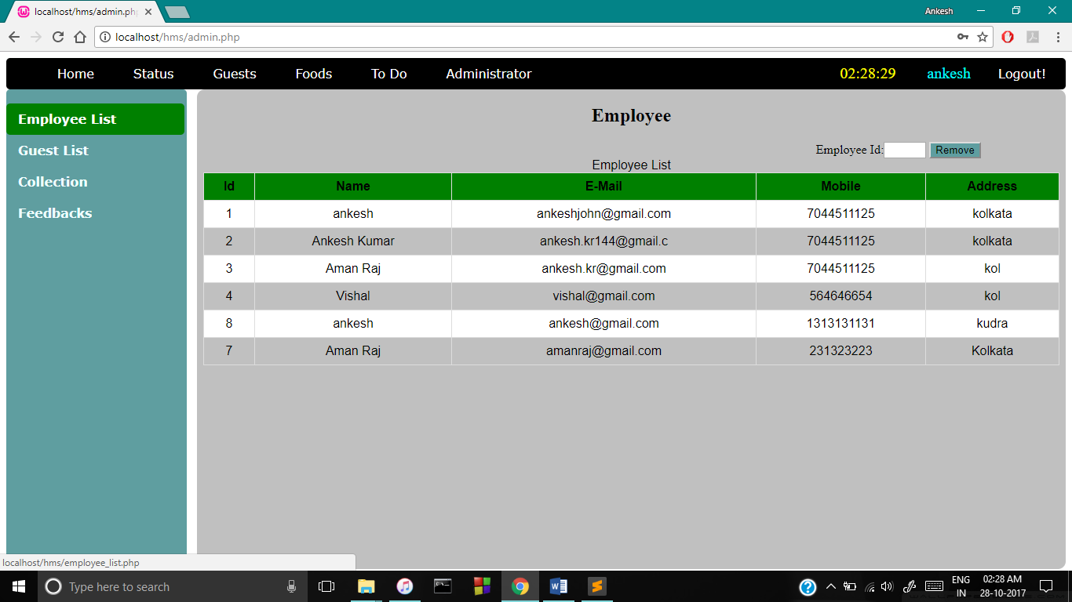

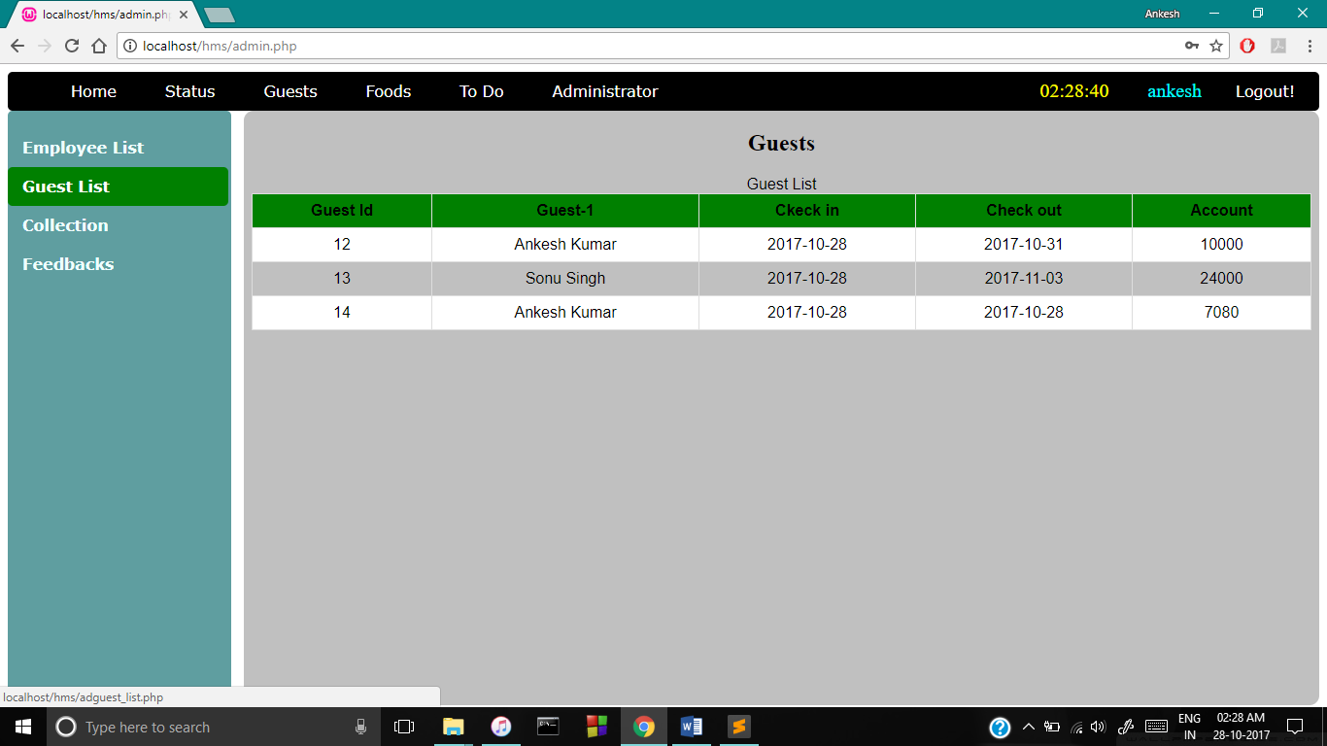

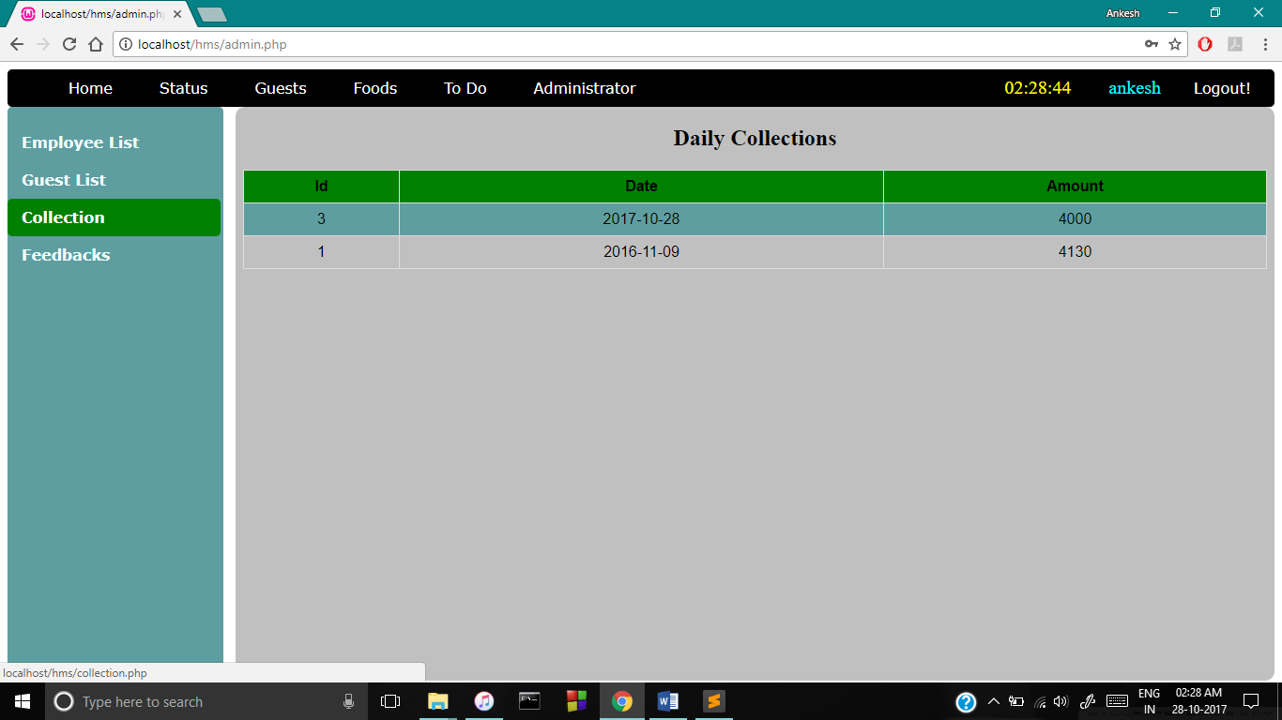

**FUTURE SCOPE**

**This system is an online system thus future scope may include**

1. **Securing passenger details from any kind of hacking.**
2. **Providing faster access to information.**
3. **Can be made reachable to people so that they can book rooms from home.**

**CONCLUSION**

**1.I have tested our software and we conclude that it works properly and can be made good use of.**

**2.My results meet our initial requirements.**

**3.The online hotel management system is user-friendly and can be used at any point of time.**

**Computer has got clear advantage over the manual system. The computerized system is more reliable, efficient and fast at the end of the project, I can say that computer play a very crucial role in the development of firm. All the daily reports generated by the system are to be checked by the concerned official so as to ensure that all the transactions have been put through in appropriate accounts and this is tallied with the new vouchers.**

**Computer does maximum work with in minimum time. Because it is used in every field so that it provides comfort and suitability to everyone. Providing maximum facilities and comfort to customers to customers is main goal of the firm. To achieve this goal, other modern facilities relating to computer should have to be provided.**